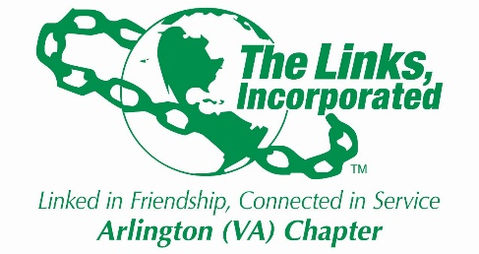
Arlington (VA) Chapter of The Links, Incorporated
June Chapter Meeting
Saturday, June 12, 11:00 a.m.
(via Zoom)

I. Call to Order Link Suzanne Walker, President

II. Linkspiration Link Cheryl Coleman Hall

III. Adoption of Agenda Link Suzanne Walker

IV. Welcome Link Suzanne Walker

V. Adoption of Minutes Link Suzanne Walker

VII. Officer Reports
President Link Suzanne Walker
Vice President Link Aleta Johnson
Recording Secretary Link Anita Walker
Corresponding Secretary Link Cheri Larkins
Financial Secretary Link Evelyn Gee
Appointed Treasurer Link Belinda LaValle

VII. Standing Committee Reports
Golf Classic & Day Party Link Erni Bridges
Monte Carlo 2022 Links Bridget Bailey Lipscomb & Candice Saunders Bylaws Link Paula Coates
Programs TBD
Chapter Retreat Links Traci Washington & Link Lisa Packer

VIII. New Business

IX. Announcements

X. Adjourn

